SMART LED DRIVER SPECIFICATIONS

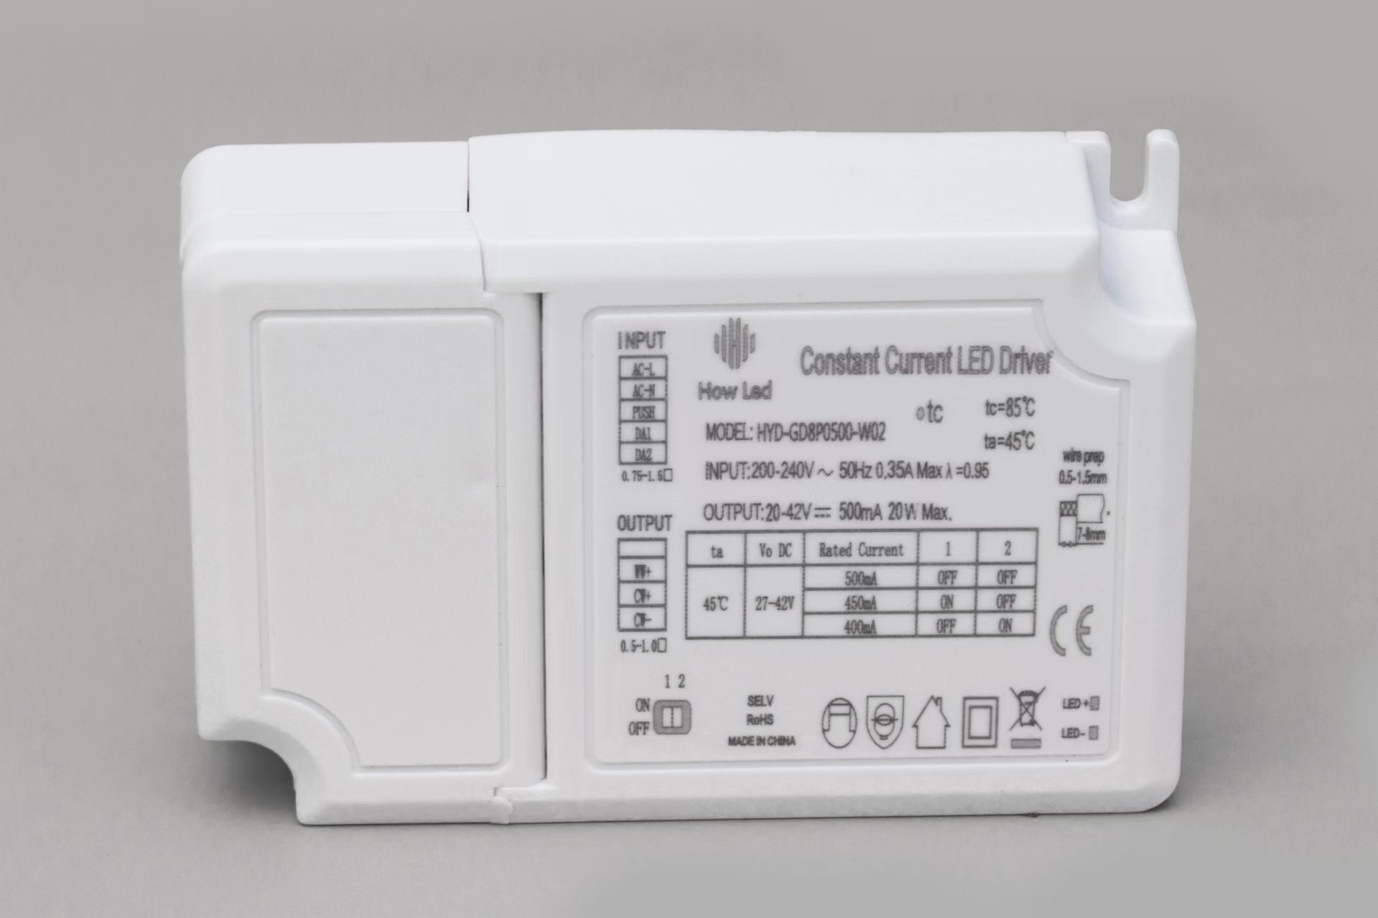
Features：
1.Universal external LED power supply
2.High power factor
3.High constant current accuracy
4.Only for indoor Model: HYD-GD8P0500-W02
5.Five years warranty

Parameters:
Model |  | HYD-GD8P0500-W02
Output | V-output Range(DC) | 20-42V
 | Constant I-output Range(A) | 470-520mA
 | Rated current | 36V
 | Rated Power | 20W
 | Ripple & noise (Note 3) | 30mV
 | Current ADJ.Range | 470-520mA
 | Voltage Accuracy
 | Line Regulation | ±5%
 | Load Regulation | ±5%
 | Time | ≤700ms
 | Dimmable Function | 0-10V DIM
Input | V-input (AC) | 230VAC
 | V-input Range | 200-240VAC
 | Frequency range | 50Hz
 | PF (Note 4) | >0.9/230VAC
 | THD | When the output load ≥ 50% 230vac THD <15%
 | Efficiency (Note 5) | >83%/230Vac
 | I-input | <0.3A max./100Vac
 | Surge Current | I<60A/200uS@230Vac
 | Leak Current | <0.75A/230Vac
 | Start-up Time | <0.5S/230VAC,at full load
Protection | Short Circuit | Hiccup Mode(Auto-Recover)
 | Open Circuit | 50V
 | Over-Temp (Note 6) | 150℃
Environment | Working Temp | -25℃ - +45℃
 | Working Humidity | 20-90%RH (no condensation)
 | Storage Temp | 10-90%RH(no condensation)
 | IP Level | N/A
 | VIBRATION  VIBRATION  VIBRATION | - -500Hz,5G 12min./1cycle,period for 72min. eachalong X,Y,Z axes
 | Tc | 83℃(ta:45℃)
 | MTBF | 50000H min.,MIL-HDBK-217F(45℃)
EMC Regulation | CE | EN 55015
 | RE | EN55015 CDN
Safety | SAFETY STANDARDS | EN61347-1，2-13;;UL1310，UL1012，UL8750
 | CERTIFICATE | N/A
 | WITHSTAND VOLTAGE | 3750V
 | ISOLATION RESISTANCE | 50MΩ
Package | Appearance Size | L103*W64*H27(mm)
 | NW
 | PCS/CTN
 | ENVIRONMENTAL PROTECTION | RoHS
NOTE
Appearance size：

H：27mm
W：64mm

L：103mm
SIDE：L*W*H=103*64*27mm

Lifespan Diagram:
In a closed space, the life of the product is calculated when the shell temperature reaches 40 °C, 50 °C, 60 °C, 70 °C, 80 °C, 85 °C

lifetime（khours）

